Analysis Challenge 6

Confounding

Miles D. Williams

2023-03-28

For this analysis challenge, you’ll be presented with a few different causal frameworks. Your task, for each case, is to use that framework to decide which variables you should control for in a multiple regression model, and which you should leave out.

For each scenario you will

1. Indicate the variables you will control for
2. Justify your choice in a short paragraph

For two, your reasoning should be guided by one of the following considerations we discussed in the lecture regarding *selection on observables* or SOO designs:

* Minimizing ommited variable bias
* Avoiding controlling for mechanisms
* Avoiding post-treatment bias

## Secnario 1

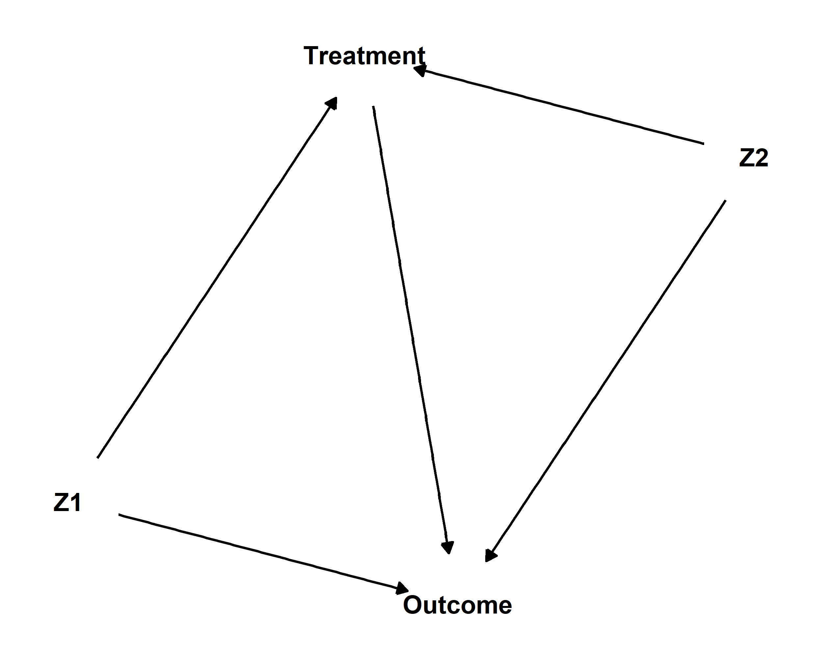

Variables you’d control for:

Reasoning:

## Scenario 2

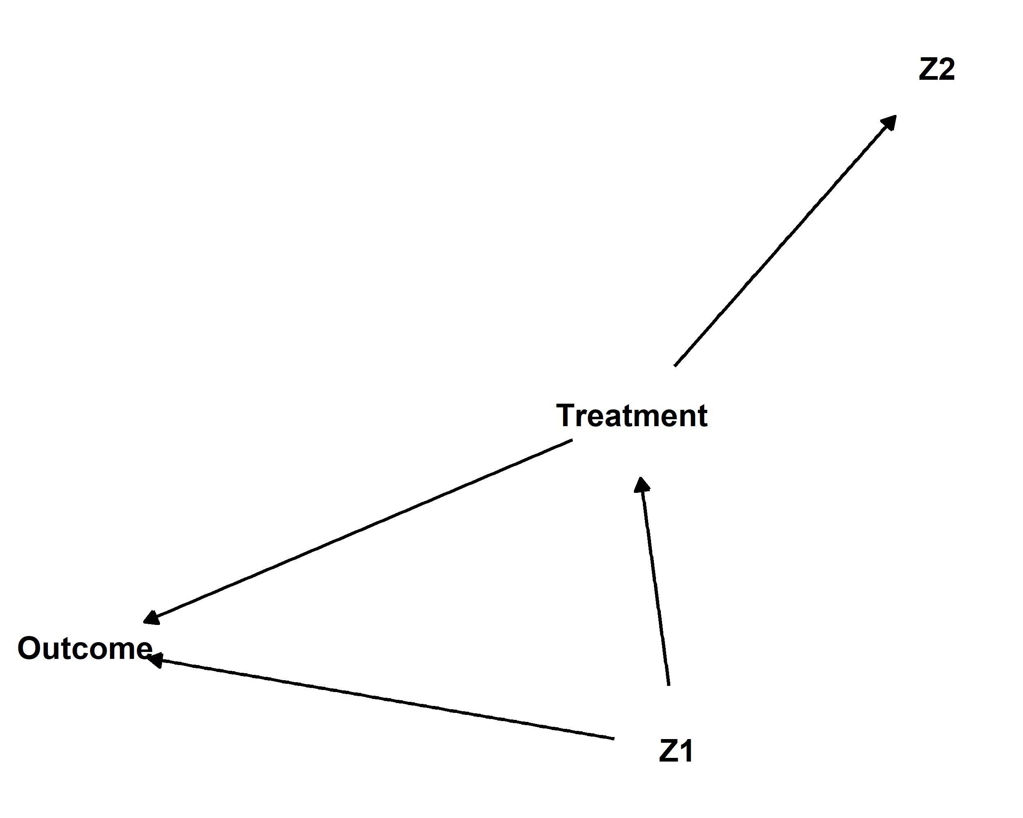

Variables you’d control for:

Reasoning:

## Scenario 3

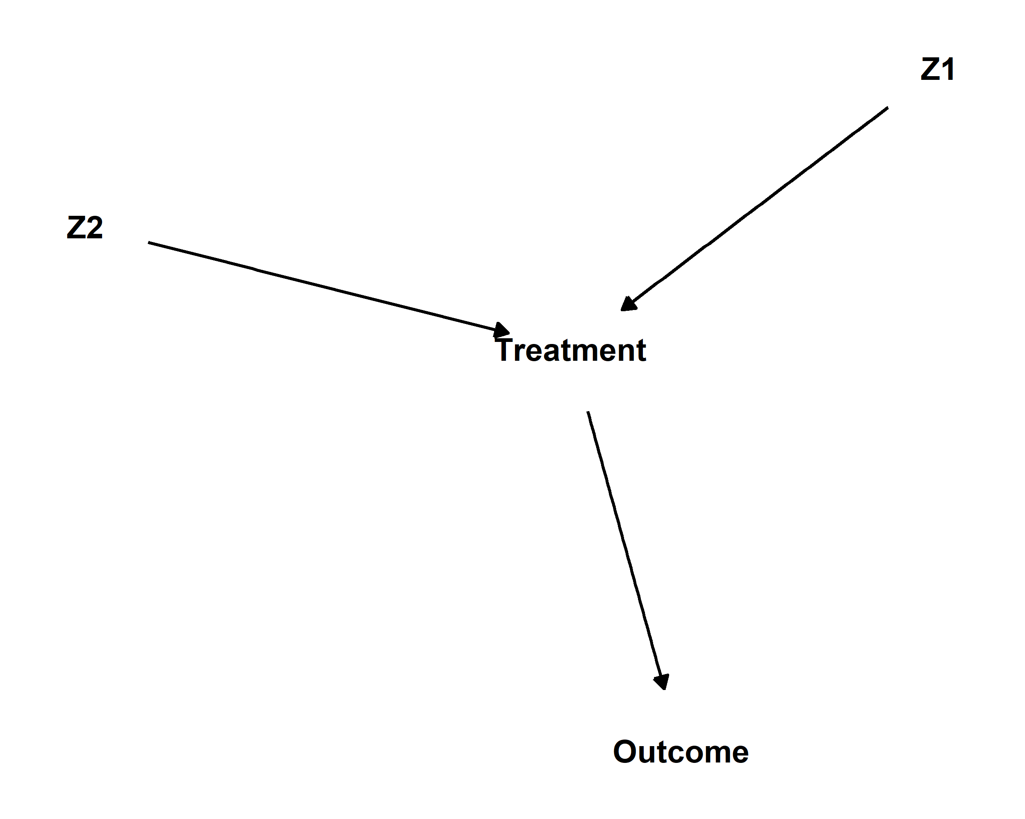

Variables you’d control for:

Reasoning:

## Scenario 4

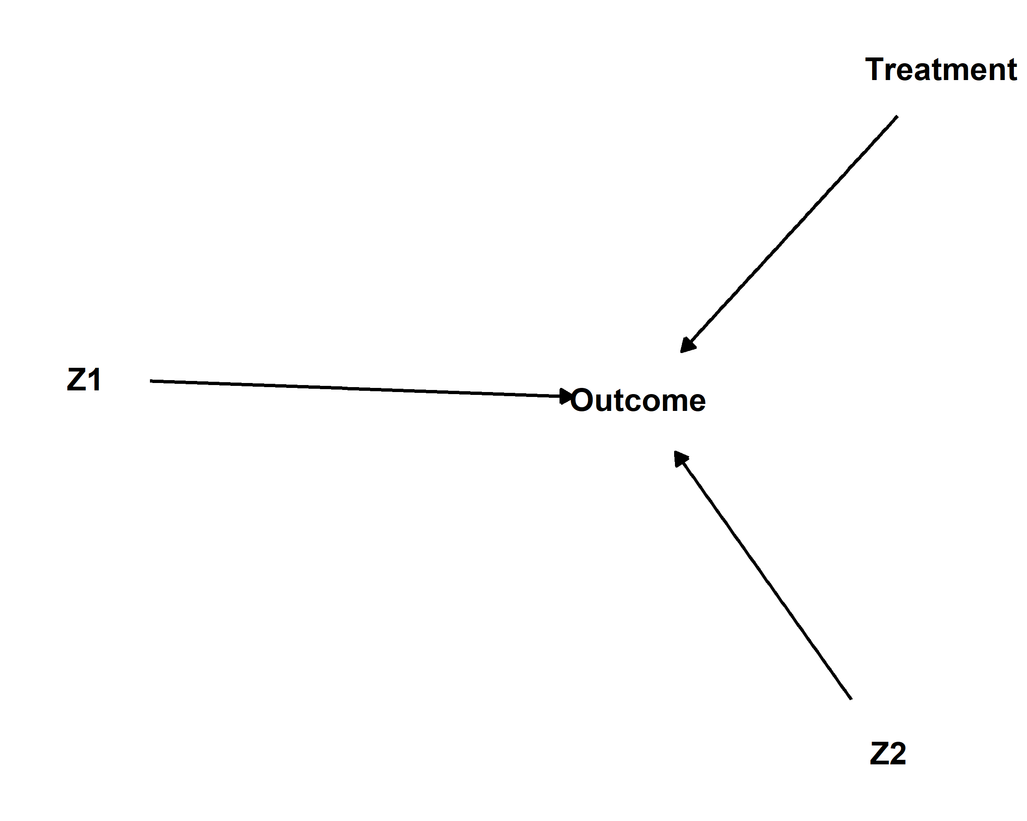

Variables you’d control for:

Reasoning:

## Scenario 5

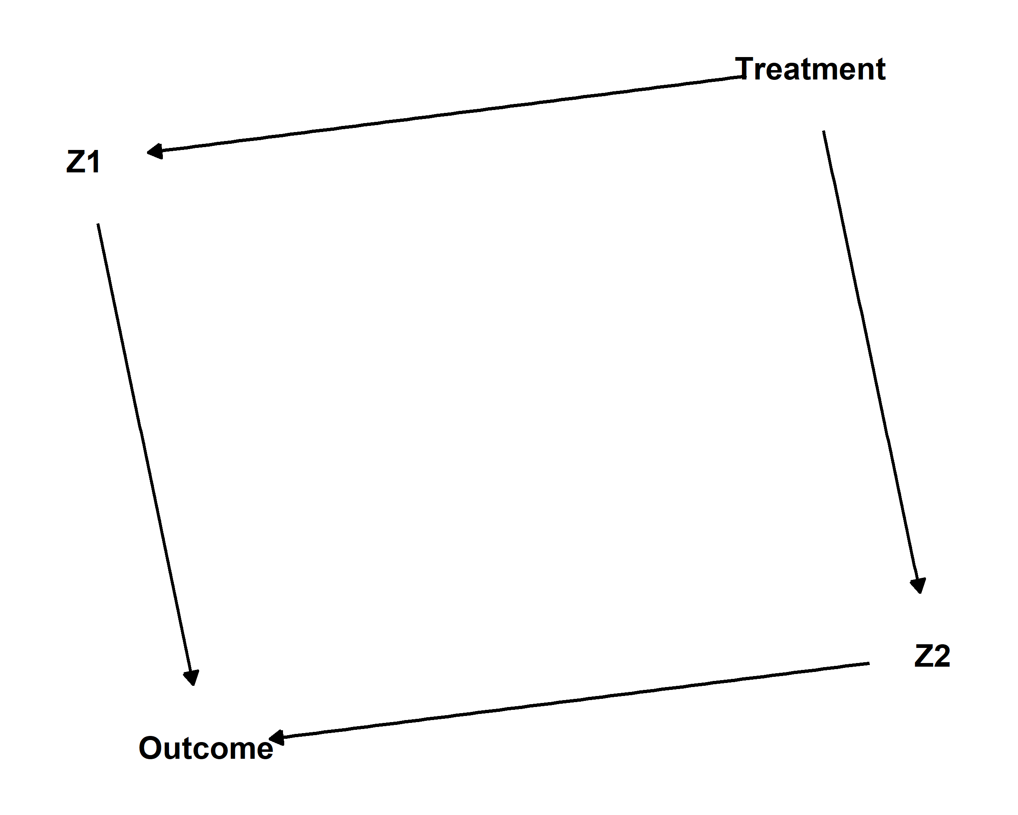

Variables you’d control for:

Reasoning:

## Scenario 6

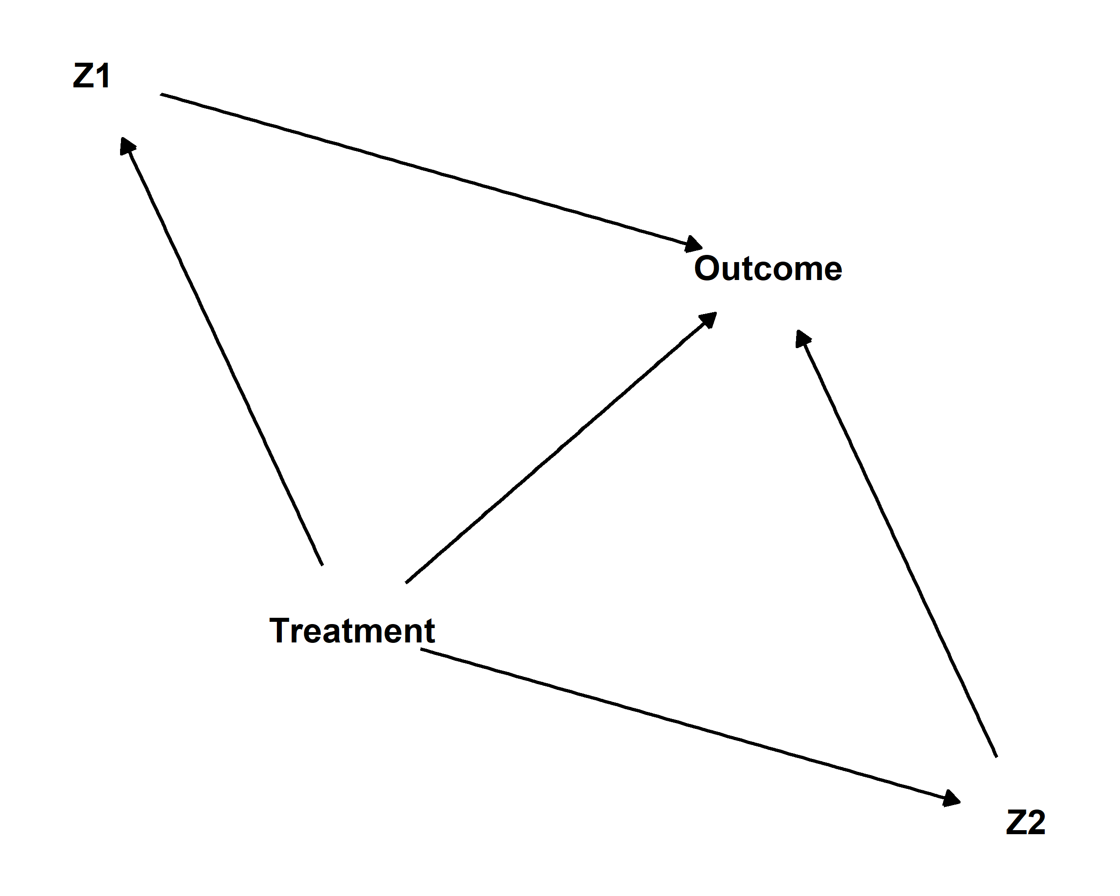

Variables you’d control for:

Reasoning: